INFORMATICA SCENERIO BASED

Convert single row from source to three rows in target

[AddThis Social Bookmark Button](http://www.addthis.com/bookmark.php)

**Scenario1:**

We have a source table containing 3 columns : Col1, Col2 and Col3. There is only 1 row in the table as follows:

|  |  |  |
| --- | --- | --- |
| Col1 | Col2 | Col3 |
| a | b | c |

There is target table containg only 1 column Col. Design a mapping so that the target table contains 3 rows as follows:

|  |
| --- |
| Col |
| a |
| b |
| c |

Without using normaliser transformation.

**Solution:**

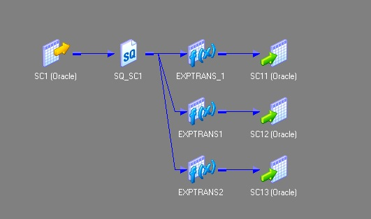

Create 3 expression transformations exp_1,exp_2 and exp_3 with 1 port each. Connect col1 from Source Qualifier to port in exp_1.Connect col2 from Source Qualifier to port in exp_2.Connect col3 from source qualifier to port in exp_3. Make 3 instances of the target. Connect port from exp_1 to target_1. Connect port from exp_2 to target_2 and connect port from exp_3 to target_3.

Split the non-key columns to separate tables with key column in both

[AddThis Social Bookmark Button](http://www.addthis.com/bookmark.php)

**Scenario 2:**

Split the non-key columns to separate tables with key column in both  / How to split the data of source table column-wise with respect to primary key. See the source and target tables below.

**source table:** ID is the key column, Name and Phone No are non-key columns

|  |  |  |
| --- | --- | --- |
| **ID** | Name | Phone No |
| 10 | AAA | 123 |
| 20 | BBB | 234 |
| 30 | CCC | 434 |
| 40 | DDD | 343 |
| 50 | EEE | 442 |

**Target Table 1**

|  |  |
| --- | --- |
| ID | Name |
| 10 | AAA |
| 20 | BBB |
| 30 | CCC |
| 40 | DDD |
| 50 | EEE |

**Target Table 2**

|  |  |
| --- | --- |
| ID | Phone No |
| 10 | 123 |
| 20 | 234 |
| 30 | 434 |
| 40 | 343 |
| 50 | 442 |

**Solution:**

Step  1: Source qualifier: get the source table to the mapping area. See image below.

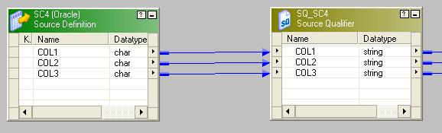

Step 2:  Drag all the port from (from the previous step) to the Aggregator transformation and group by the key column. Since we have to split the columns to two different tables with the key column in each, so we are going use two expression transformation, each will take the key column and one non-key column. Connect  aggregator transformation with each of the expression transformation as follows.

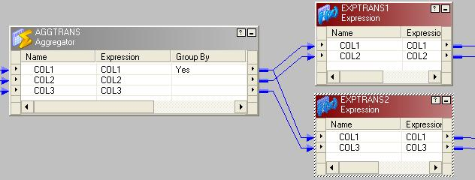

Step 3: We need another set of  aggregator to be associated with each of the expression tranformation from the previous step.

Step 4: In the final step connect the aggregators with the two target tables as follows.

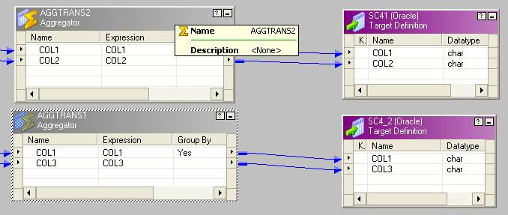

Here is the iconic view of the entire mapping.

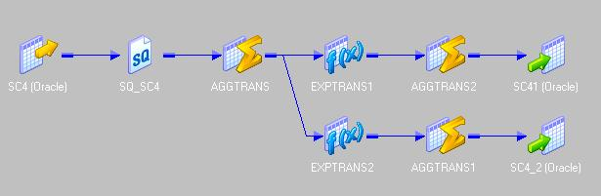

Separating duplicate and non-duplicate rows to separate tables

[AddThis Social Bookmark Button](http://www.addthis.com/bookmark.php)

**Scenario 3:**

How to segregate the duplicate and distinct rows from source table to separate target tables?

**source table:**

|  |  |  |
| --- | --- | --- |
| **COL1** | COL2 | COL3 |
| a | b | c |
| x | y | z |
| a | b | c |
| r | f | u |
| a | b | c |
| v | f | r |
| v | f | r |

**Target Table 1**: Table containing all the unique rows

|  |  |  |
| --- | --- | --- |
| COL1 | COL2 | COL3 |
| a | b | c |
| x | y | z |
| r | f | u |
| v | f | r |

**Target Table 2:** Table containing all the duplicate rows

|  |  |  |
| --- | --- | --- |
| COL1 | COL2 | COL3 |
| a | b | c |
| a | b | c |
| v | f | r |

**Solution:**

Step  1: Drag  the source to mapping and connect it to an aggregator transformation.

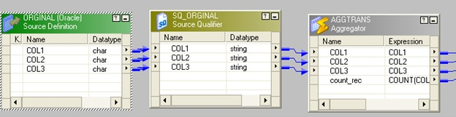

Step  2: In aggregator transformation, group by the key column and add a new port  call it count_rec to count  the key column.

Step  3: connect  a router to the  aggregator from the previous step.In router make two groups one named "original" and another as "duplicate"  
In original write count_rec=1 and in duplicate write count_rec>1.

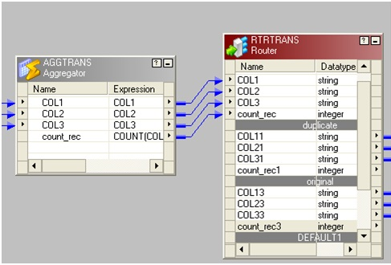

The picture below depicting group name and the filter conditions

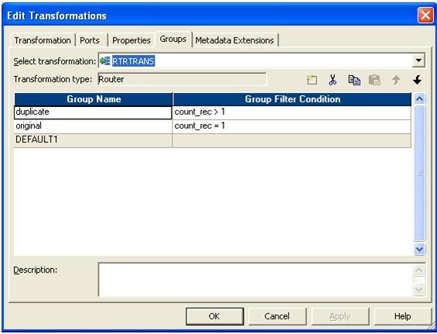

Step 4: Connect two group to corresponding target table.

